Strategies, Use, and Impact of Social Media for Supporting Teacher Community within Professional Development: The Case of one Urban STEM Program

Journal of Computers in Mathematics and Science Teaching

Special Issue on MSU UrbanSTEM Teacher Professional Development Fellowship Program

Author Note

Joshua M. Rosenberg, Department of Counseling, Educational Psychology, and Special Education, Michigan State University.

Spencer P. Greenhalgh, Department of Counseling, Educational Psychology, and Special Education, Michigan State University.

Leigh Graves Wolf, Hub for Innovation in Learning and Technology, Michigan State University.

Matthew J. Koehler, Department of Counseling, Educational Psychology, and Special Education, Michigan State University.

Correspondence concerning this article should be addressed to Joshua M. Rosenberg, College of Education, 447 Erickson Hall, 620 Farm Lane, East Lansing, MI 48824

Email: jrosen@msu.edu

**Abstract**

This paper examines the use of social media to foster community connections within the MSU Urban Science, Technology, Engineering, and Mathematics (STEM) program. We describe the strategies employed by the program and the technologies employed by instructors to provide support, build community, and showcase learning. We highlight three particular tools used to foster community within the program: Facebook, websites and blogs, and Twitter and then use trace data from Twitter to demonstrate how social media fostered community within the program. We conclude with a description of implications for how social media is used to support community for future research and practice.

*Keywords*: Social media, online community, #MSUrbanSTEM, social network analysis, Twitter, graduate education.

Strategies, Use, and Impact of Social Media for Supporting Teacher Community within Professional Development: The Case of one Urban STEM Program

Social media is recognized for its ability to contribute to teachers’ learning and sense of professional community. It has long been recognized that digital technologies allow teachers to communicate with and learn from teachers in other locations (Merseth, 1991). However, this does not guarantee that community—an important element in distance learning—exists within distance learning settings (Haythornthwaite, Kazmer, Robins, & Shoemaker, 2000). In response, teachers and teacher educators are increasingly using social media as part of teacher professional development efforts—not only to transmit information but also to help create powerful support networks and communities for educators(Couros, 2010; Carpenter & Krutka, 2014). Indeed, digital technologies such as social media can have an important influence on how community—and related concepts such as social capital—are experienced (Katz, Rice, Acord, Dasgupta, & David, 2004).

In this paper, we explore these issues at the intersection of communities, social media, and teacher professional development in the context of the MSU UrbanSTEM program. Although some portions of the UrbanSTEM program are held in face-to-face settings, much learning takes place on line, creating a need to continue community ties during this time. We specifically highlight how the design, instructional goals, and curriculum of the program align with the practices and uses of social media—i.e., technologies used to create and maintain social connections—to help develop and foster a learning community for teachers.

We first describe the impetus for our use of these communication tools and platforms and provide a broad description of their characteristics and uses. This description is followed by a brief study of how three particular social media—a private Facebook group, websites and blogs, and the hashtag #MSUrbanSTEM on Twitter—serve as exemplars and case studies of how communication tools can support community. We conclude with recommendations for how both practitioners and researchers might consider the use of communication tools to support community in graduate programs and similar settings.

**Values, Goals, and Strategies for Social Media Use**

Throughout its existence, the MSU Urban Science, Technology, Engineering, and Mathematics (STEM) program intentionally embedded social media into the learning experience in order to foster community and network connections. The use of social media in the MSU UrbanSTEM program was specifically informed by the larger Master of Arts in Educational Technology (MAET) graduate program, which uses social media as an integral piece of student experience (Terry, Mishra, Henriksen, Wolf, & Kereluik, 2013).

Based upon these earlier experiences, the UrbanSTEM certificate program put a high value on prompt and effective communication. If a student was struggling or discouraged during their time in the program, we wanted to provide a just-in-time mechanism for them to get support and encouragement from peers and instructors. However, we also hoped that students would create a community while in the program that would last far beyond their completion of the certificate, and we used program activities to encourage the creation of this community. Program instructors identified and employed several private and public social technologies to accomplish these goals. Table 1 describes each of these communication tools and explains how each served a distinct need.

For the purposes of advising, the fellows were grouped into teams of ten and assigned an advisor from the instructional team. While fellows often collaborated across these teams, their advisor was primarily responsible for feedback on their individual assignments (mediated via email and Google collaborative software) and providing guidance and support as they implemented projects. During the course of the certificate program, advisors met on a bi-weekly basis via teleconference for instructional team meetings. During these meetings, advisors would report celebrations and concerns about the fellows. In reflections from the instructional team, it was often expressed that text messages provided a level of connection and support that prompted a deeper (and more prompt) connection over other forms of course communication.

**How Social Media Were Used**

In this section, we discuss how three social media tools were used by instructors to foster community. We first discuss how Facebook was used as a tool to privately build community within the UrbanSTEM certificate program; then, we explain how websites and blogs associated with the program served to open that community to the broader population of teachers in Chicago Public Schools. Finally, we show how the #MSUrbanSTEM hashtag on Twitter was used to build community within and beyond the certificate program.

**Facebook Group**

One of the tools instructors and fellows used to foster community amongst themselves was a private Facebook group. Facebook posts served to create presence as well as a place to provide and receive support; more specifically, fellows could ask questions and provide resources (see Figure 1). Because this group was private, it reinforced the idea of the certificate program as a specific and contained community of trusted insiders.

**Websites and Blogs**

Websites and blogs associated with the UrbanSTEM program reinforced this sense of community while opening it to others. We employed a digital content curator for the official program website and blog (<http://msuurbanstem.com>); she closely monitored social media and created public blog posts to curate the successes and content that fellows and instructors shared. The program website also links to individual websites where fellows publicly shared their own work. This frequent and intentional sharing—on both program and individual levels—is an important keystone to the program’s communication and community strategy. Although the certificate program was limited to 125 fellows, it was our intention to benefit as many teachers in Chicago Public Schools as possible by publicly sharing fellows’ work as well as all course content (http://www.msuurbanstem.org/teamone/).

**#MSUrbanSTEM on Twitter**

The #MSUrbanSTEM hashtag on Twitter further served to foster community between and beyond instructors and fellows. Hashtags are used on Twitter to organize and coordinate discussions on a single topic. That is, by appending #MSUrbanSTEM to their tweets, fellows and instructors marked them as related to the program; by searching for that same term, Twitter users could break out of their main *feed* of tweets to focus on just those on this topic. However, because tweets are public by default, these discussions were not limited to those formally affiliated with the program, inviting others to connect with the community and participate in its interactions.

**Impact of Social Media**

To describe the impact of social media on community within the UrbanSTEM program, we examine data associated with the #MSUrbanSTEM hashtag on Twitter. We treat this data as “digital traces” (Welser, Smith, Fisher, & Gleave, 2008) of social interactions and community within the certificate program; although the other social media described in this paper could also provide such traces, Twitter data is the most easily accessible and best demonstrates social interactions both within and beyond the program. We collected tweets and *retweets* (i.e., reposts of a tweet) using #MSUrbanSTEM between August 14, 2014 and June 31, 2016, beginning about a month after the beginning of the first cohort and continuing through the completion of the second cohort. As a result of some technical and other difficulties, this does not represent all of the tweets and retweets associated with the MSU UrbanSTEM program during this time. In collecting these tweets, we retrieved their content, timestamps, associated usernames, and additional trace data related to interactions.

The number and rate of #MSUrbanSTEM tweets provides an initial indication as to how Twitter supported community within the certificate program. Between August 14, 2014 and June 31, 2016, users posted 3,417 tweets and retweets, which comes out to almost 5 posts per day. These high levels of activity demonstrate that Twitter was constantly used for communication, suggesting that tweeting was a regular practice and that program members anticipated an audience for their posts, both of which indicate community ties within the program. Figure 2 shows the number of tweets per day over this time, lending additional insight into the community demonstrated in these data. For example, a period during the Spring 2015 semester stands out for its very low activity: This was when the MSU UrbanSTEM community switched to a different hashtag due to spam on the #MSUrbanSTEM hashtag. This suggests that the rate of Twitter activity within the program may have actually been higher than the figures we present here. Furthermore, the spikes of activity throughout this timeframe appear to correspond with face-to-face meetings between cohorts; the fact that Twitter was used in both face-to-face and distance settings suggests that it served to provide a link between learning and community experiences that could otherwise be seen as distinct.

Examining the days of the week and hours of the day that tweets were composed (see Figure 3) gives further insight into the importance placed by community members on shared communication and professional development. Most #MSUrbanSTEM tweets were composed between 7 am and 8 pm, with peak times around 9am and 11am. Much of this time is during the school day; this may suggest that teachers reached out to the program during their normal work responsibilities, indicating that they found communication with their peers valuable in supporting their professional responsibilities. However, the large proportion of tweets composed on Saturday presents an alternative possibility, that teachers often spend considerable time on weekend maintaining connections with their peers in both face-to-face and virtual settings; this possibility also highlights the perceived importance of intra-program activities, further suggesting a sense of shared community.

Network diagrams provide more detailed insight as to the community ties that existed within these program cohorts. Figure 4 shows *endorsing* interactions, which we measured in the form of *retweets* and *favorites* (a mechanism for acknowledging or approving tweets) and may indicate agreeing with or approving the content of a tweet, a form of informal encouragement and feedback between community members. Endorsing seems to be very regular among *Instructional Team* members and between *Instructional Team* members and *1st* and *2nd* *Cohort Members*. This suggests that members of the *Instructional Team* worked closely with each other to set a foundation for community and to show that example to the cohorts; the ties between members of the instructional team and cohort members further suggests that the instructional team regularly provided informal encouragement and feedback to members of the certificate program.

Figure 5 shows *conversing* interactions, which we measured in the form of *mentions* and *replies*—two ways of including others’ usernames in a tweet. *Conversing* seems both to be less frequent overall and to occur less regularly than *endorsing* among *Instructional Team* and *Cohort Members*. This may suggest that while Twitter was effective for maintaining community ties through basic expressions of approval and feedback, cohort members were more likely to use other social technologies for more involved conversations.

These network diagrams also highlight the community role of participants coded as *Other*—i.e., those not formally affiliated with the UrbanSTEM program. The large number of these participants shows that Twitter did help the certificate program open and expand its community to other populations, even if the peripheral position of these participants on the diagrams show that they were less active and less central in community interactions. However, there are cases in which these participants have large impacts. For example, in the network for *conversing* (Figure 5), one organization sent a tweet which was subsequently interacted with by many other participants who otherwise might not have been aware of the network or have interacted with #MSUrbanSTEM tweets in any way. This organization could be considered a community broker in that they gave the UrbanSTEM community more representation and created the possibility for further social interaction between the program participants and outside individuals or groups.

**Conclusion**

In this paper, we focused on how communication tools and platforms helped to support the development of community across—and beyond—the UrbanSTEM program. First, we identified the various tools and modes of communication used across the program; then, we identified evidence for how a private Facebook group, program websites, and the #MSUrbanSTEM hashtag were used to support the development of community. In particular, the data from Twitter provides a view of both social interactions within the community and connections with individuals outside the formal program.

Our analysis and findings have a number of implications for future research and practice related to the relationship between communication tools and community development. First, different communication and social media tools offer different affordances for research. Our focus on Twitter in this paper as a data source for demonstrating community ties is due to the relative ease of using the Twitter Application Programming Interface to access Twitter data. While it is possible to obtain data from other sources, such as Facebook, privacy settings make doing so difficult, and the data obtained is often too limited to be useful. Second, reliably collecting data on Twitter requires forethought and monitoring, as evidenced by some of the gaps in our data collection. For example, at the time of publication, the freely available Twitter API only provides data for the seven most recent days; researchers must either plan data collection carefully or use other, sometimes expensive, tools to collect tweets from the past. In addition, to guard against missing data, it is important to continuously monitor both Twitter activity and the collection process in order to identify instances in which other hashtags are used or the tracker does not work.

In terms of practice, we recommend that those designing, developing, or teaching in professional development programs use a variety of communication and social media tools to support the development of community. In particular, social media platforms may serve as tools through which teachers are given opportunities to share work carried out as part of the program or in teachers’ classrooms and to participate in rich discussions about aspects of the program and other topics. We also recommend that programs provide opportunities for members of different years or cohorts to interact. These types of interactions can help more novice learners learn from and be supported by those who are more experienced. They also allow those with more experience to continue to be engaged long after they complete their degrees or certificates.

Future research might investigate the affordances of tools for specific outcomes and more deeply investigate the development of community that we have briefly visited here. As the landscape of available communication tools grows and changes, so should those used in teacher professional development to build, maintain, and strengthen communities. Research should explore these new tools and determine which outcomes—including community but also learning outcomes such as teacher knowledge and leadership—they might afford. This social network analysis of Twitter interactions allows us a preliminary window into evidence of community. However, further qualitative and quantitative investigation of these (and other) data could allow for a richer understanding of community in these spaces, including an analysis of interactions between ideas, not just network actors.

References

Carpenter, J. P., & Krutka, D. G. (2014). How and why educators use Twitter: A survey of the field. *Journal of Research on Technology in Education*, *46*, 414-434, doi:10.1080/15391523.2014.925701

Couros, A. (2010). Developing personal learning networks for open and social learning. In G. Veletsianos (Ed.), *Emerging technologies in distance education* (pp. 109–128). Edmonton, Alberta: AU Press

Haythornthwaite, C., Kazmer, M. M. Robins, J., & Shoemaker, S. (2000). Community development among distance learners: Temporal and technological dimensions. *Journal of Computer-mediated Communication*, *6*(1). doi:10.1111/j.1083-6101.2000.tb00114.x

Merseth, K. K. (1991). Supporting beginning teachers with computer networks. *Journal of Teacher Education*, *42*, 140-147. doi:10.1177/002248719104200207

Terry, L., Mishra, P., Henriksen, D., Wolf, L.G., Kereluik, K. (2013).Making it meaningful: The reciprocal relationship between technology and psychology. *TechTrends, 57*(3), 34-39.

Welser, H. T., Smith, M., Fisher, D., & Gleave, E. (2008). Distilling digital traces: Computational social science approaches to studying the internet. In N. Fielding, R. M. Lee, & G. Blank (Eds.), *The SAGE handbook of online research methods* (pp. 116–141). Thousand Oaks: SAGE Publications, Ltd.

Tables

Table 1

*Tools or Modes of Communication to Foster Community Across the UrbanSTEM Program*

|  |  |
| --- | --- |
| Tool or Mode of Communication | Description |
| Public blogs | Each fellow was required to have a public-facing web presence to share their work. Fellows’ websites can be found by visiting <http://www.msuurbanstem.org/cohorts/> |
| Program website and blog | MSUrbanSTEM teaching was mediated via a public-facing program site, and a digital content curator was hired to blog about the accomplishments of the fellows: <http://www.msuurbanstem.org/category/urban-stem/> |
| Private and group emails | A weekly email was sent to fellows to highlight their successes and work and to provide reminders for deadlines. There was a single email address for the program and all instructional team members had access to the inbox to manage communications. |
| Text messages and phone calls | Individual members of the instructional team used text messaging and phone calls to provide one-on-one to the fellows. |
| Private Facebook group | A private Facebook group provided a collective space for all MSUrbanSTEM cohorts to communicate and share information and inspiration. |
| Twitter hashtag | Fellows and instructors were encouraged to use Twitter and to employ the #MSUrbanSTEM hashtag whenever they tweeted about the program. |

Figures

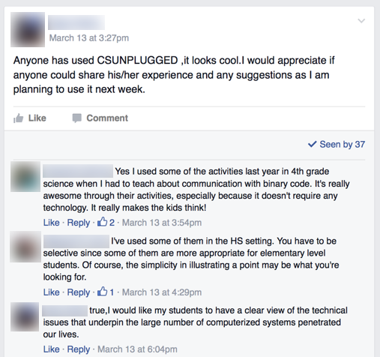

*Figure 1*. Example of a post to the private MSU UrbanSTEM Facebook group, in which one fellow is asking a question and other fellows are providing support.

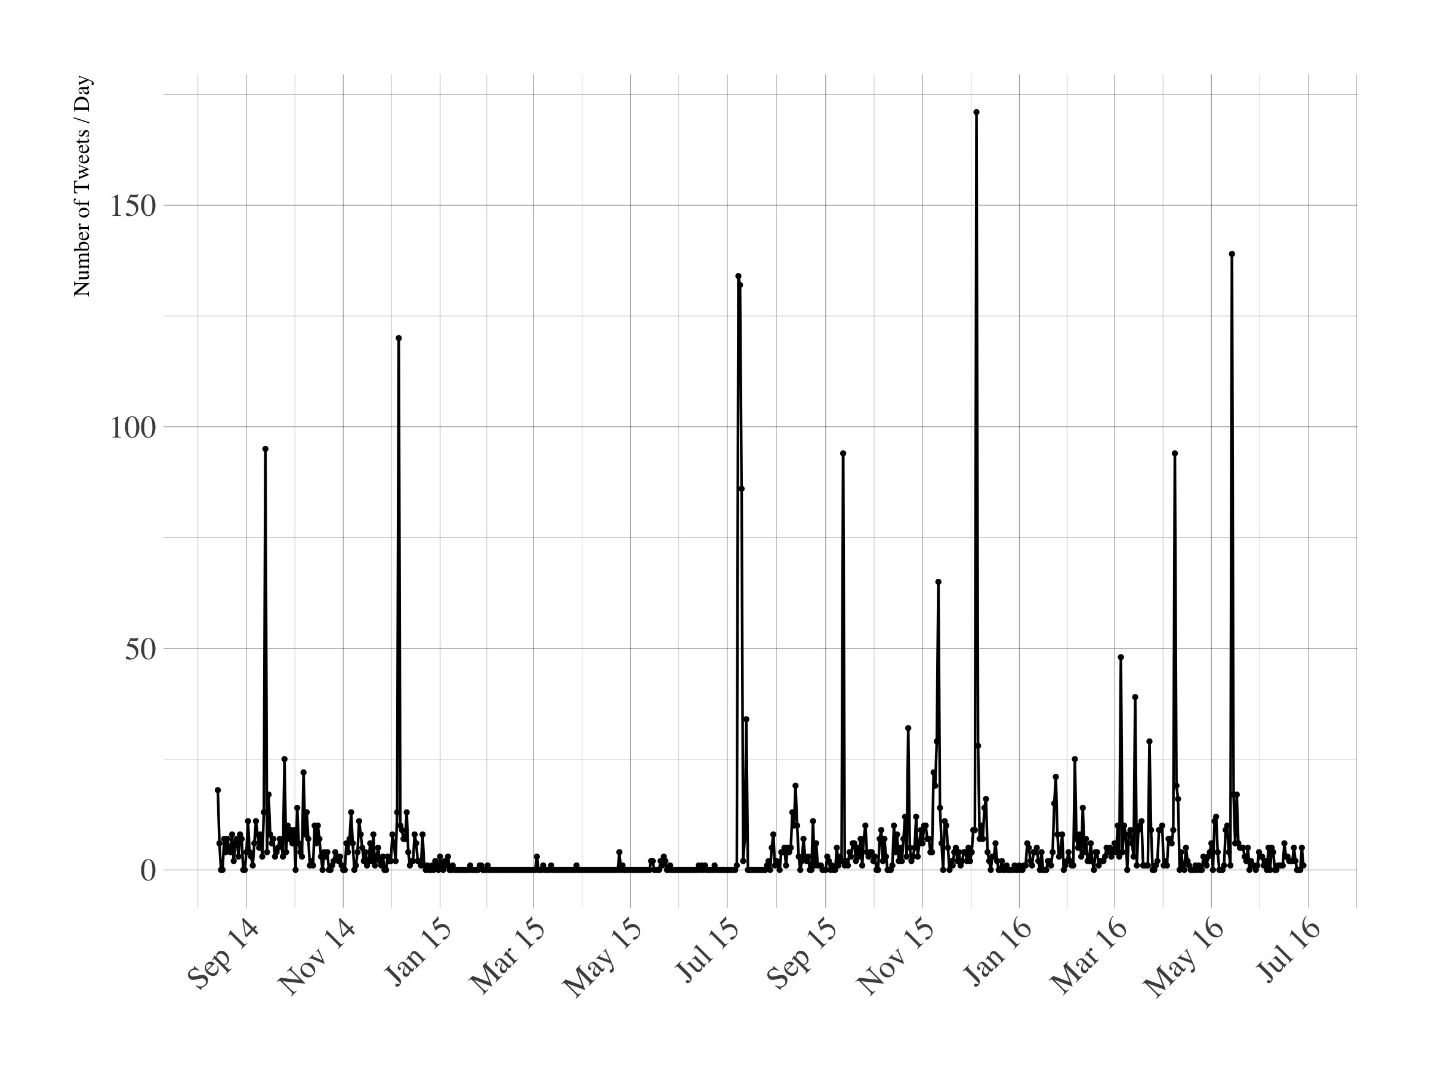

*Figure 2.*Number of tweets per day using the #MSUrbanSTEM hashtag from August 14, 2014 to June 31, 2016.

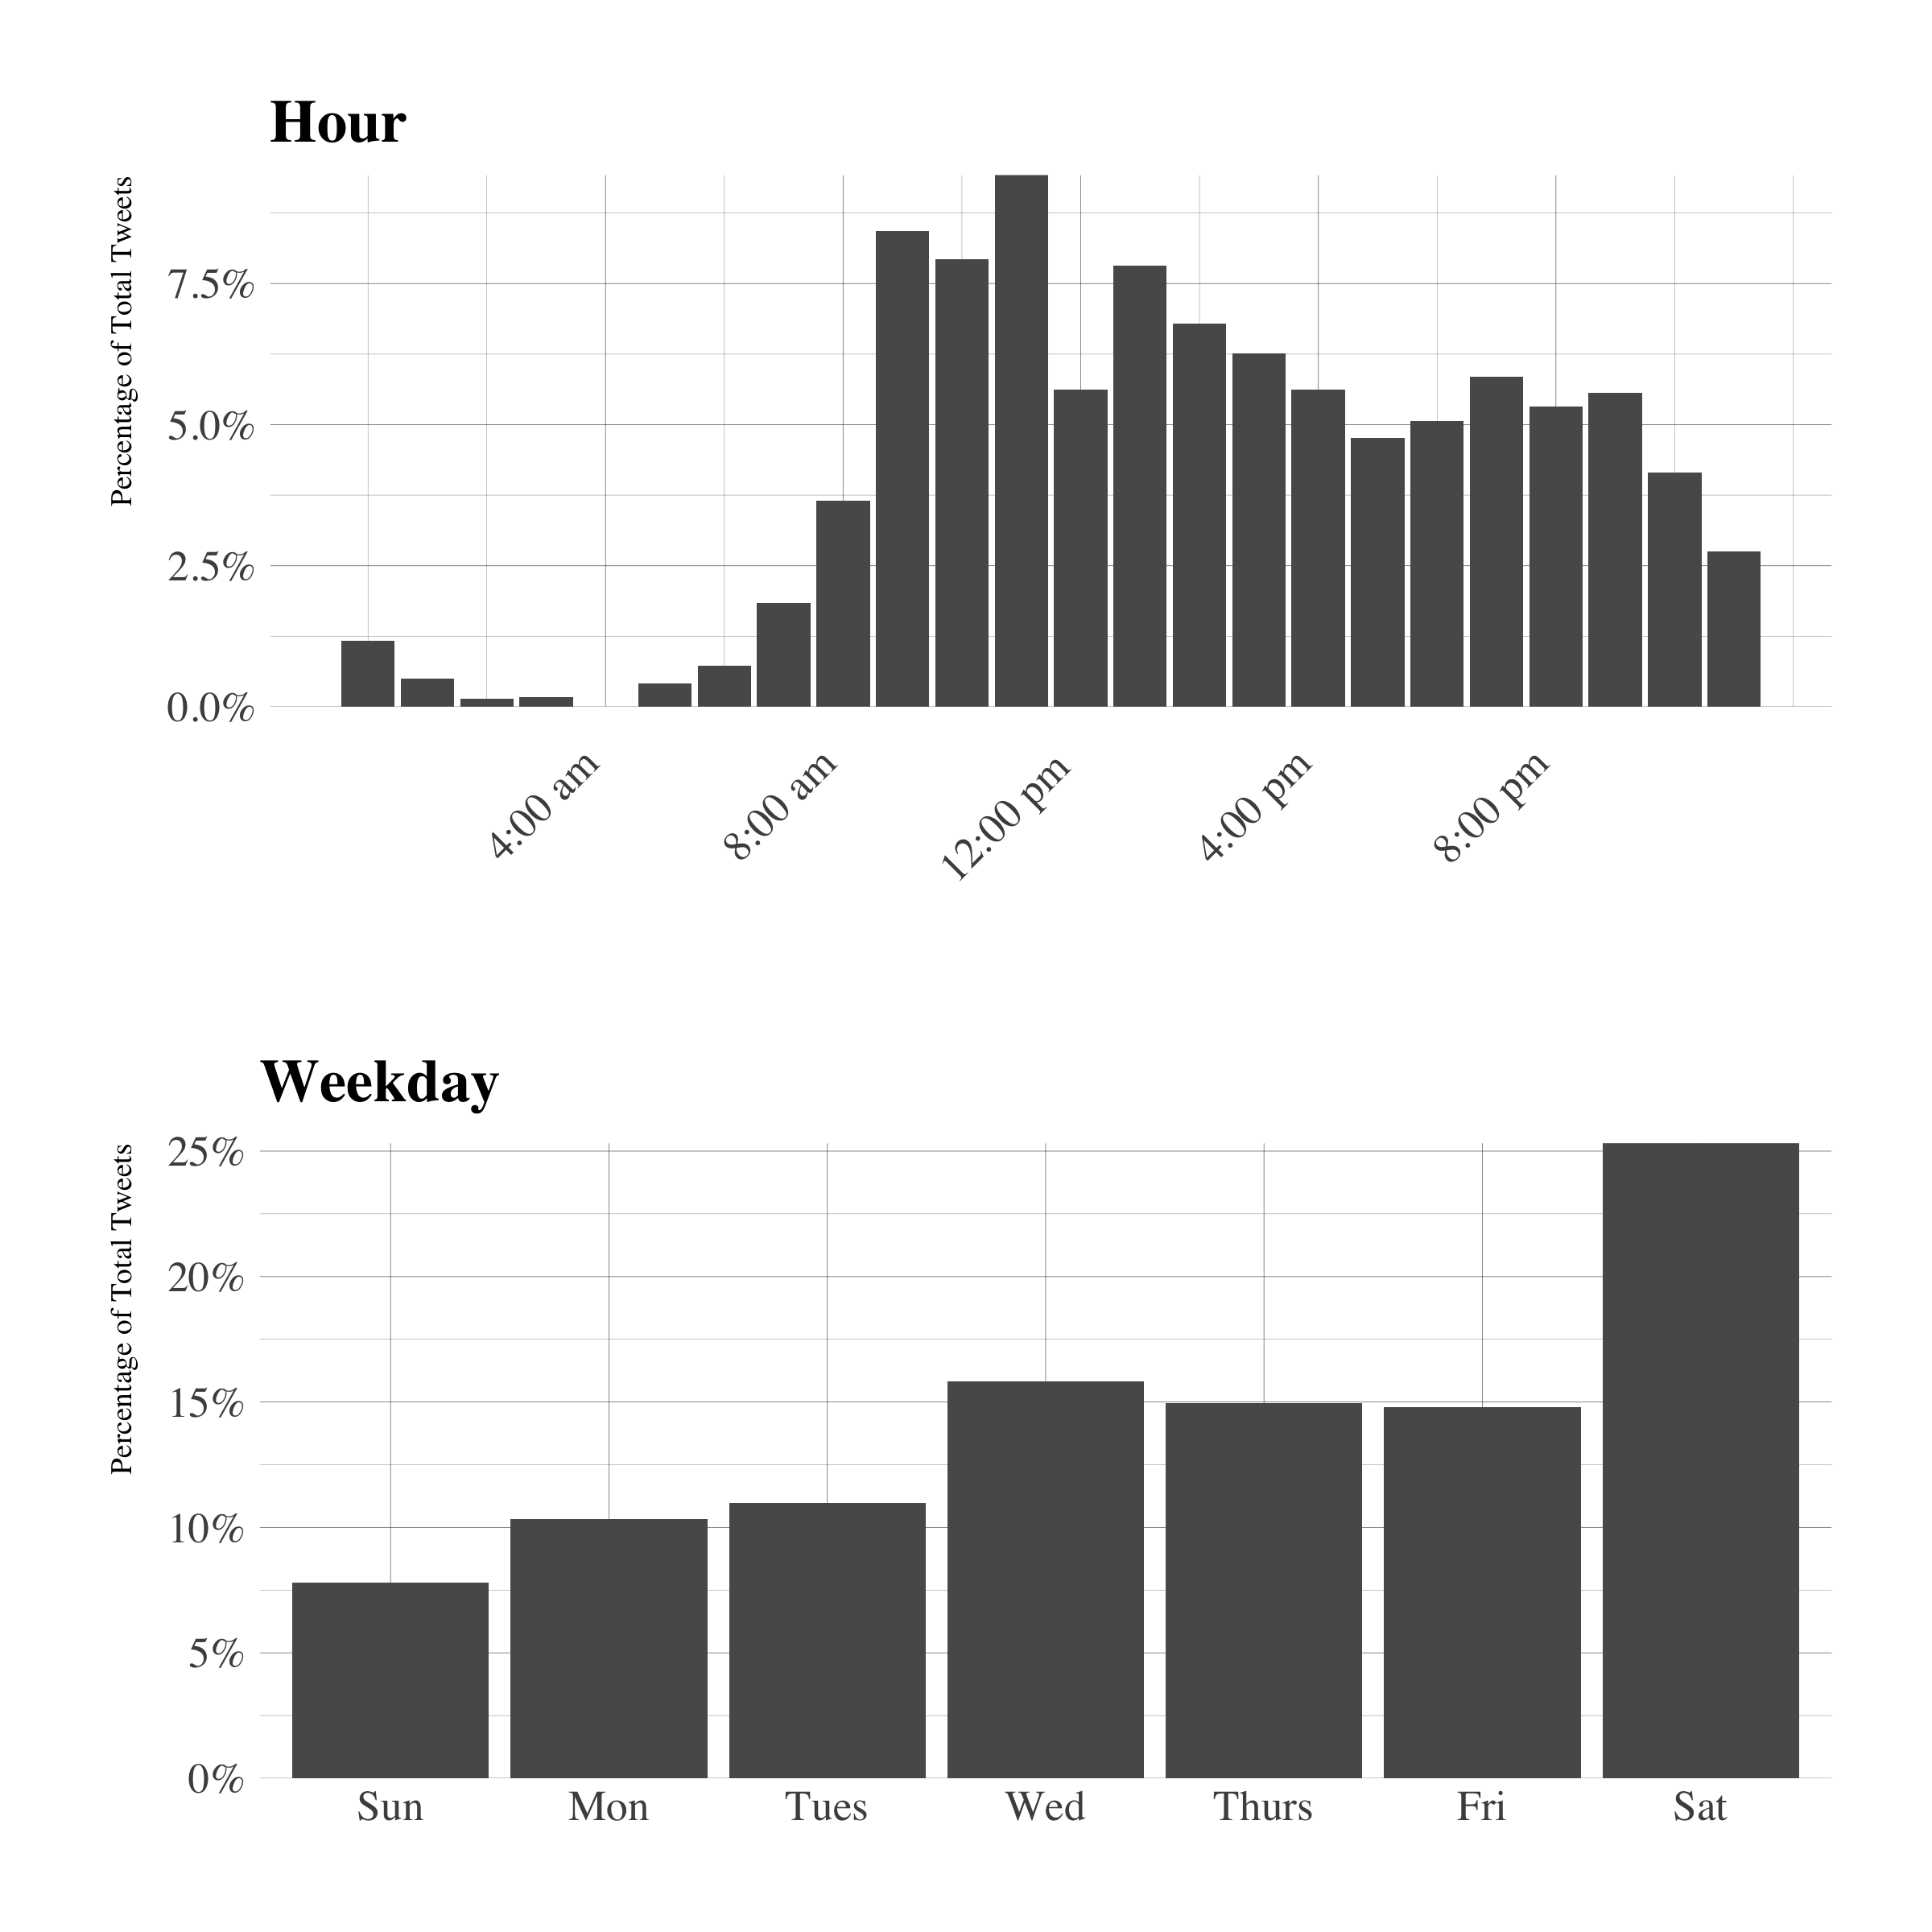

*Figure 3.*Percentage of tweets using the #MSUrbanSTEM hashtag composed each hour of the day and each day of the week.

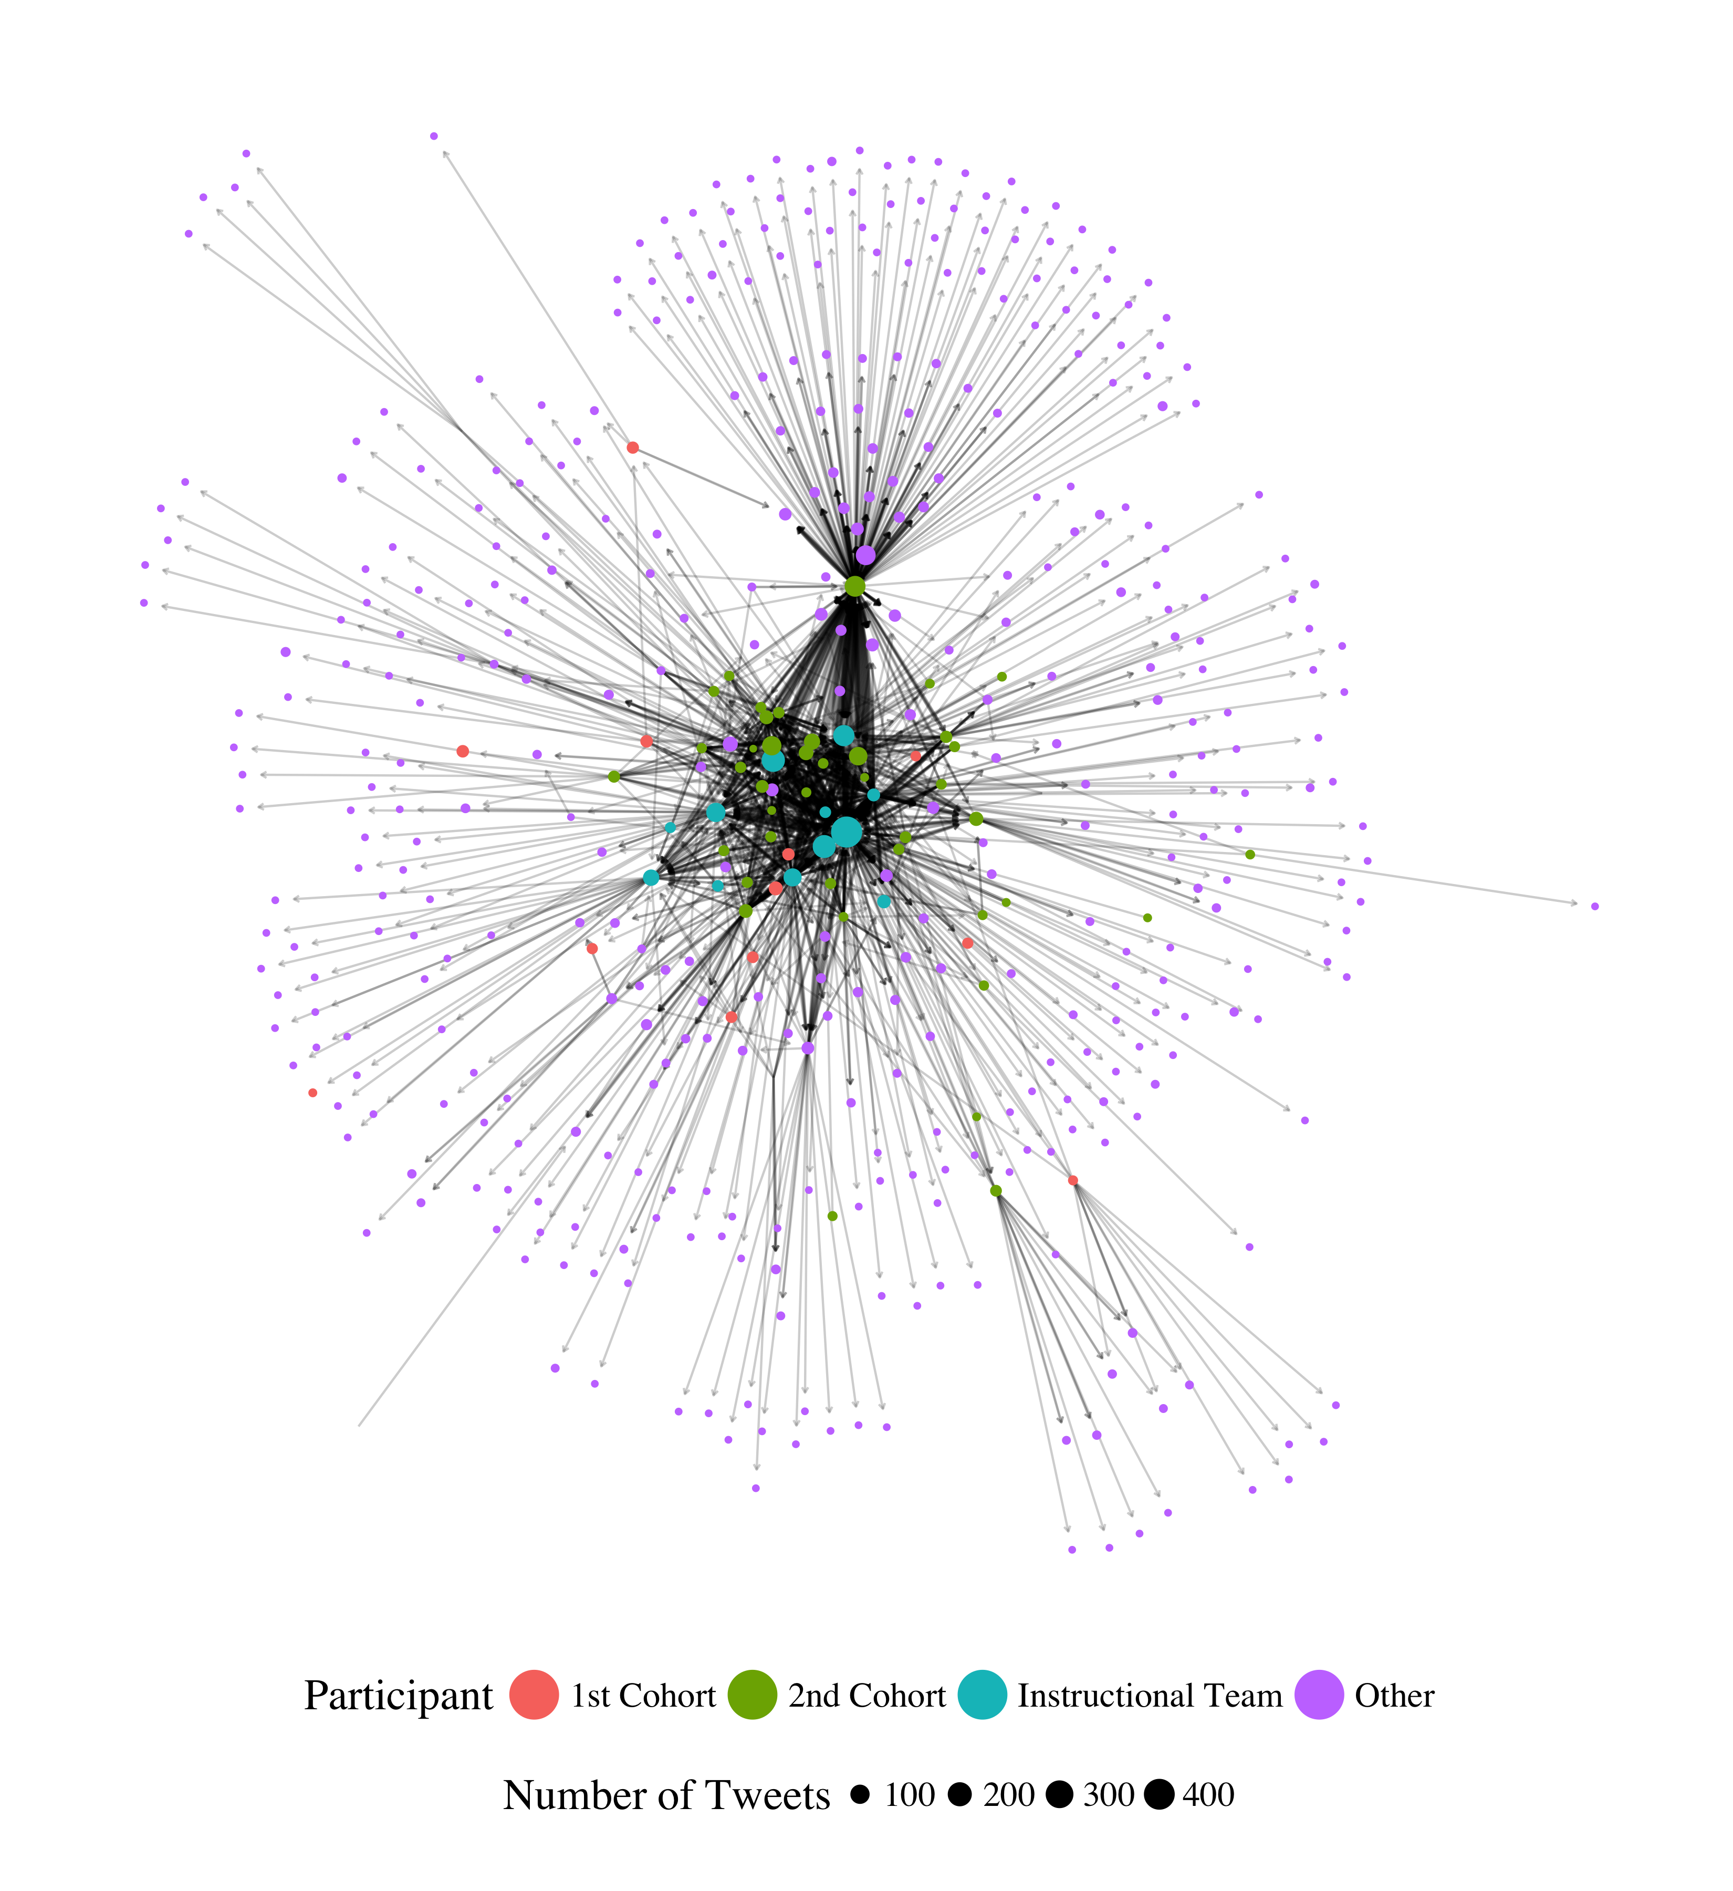

*Figure 4.* Sociogram depicting endorsement patterns within the #MSUrbanSTEM hashtag for UrbanSTEM cohorts 1 and 2.

Note. In this analysis, every participant who endorsed (retweeted or favorite) a tweet with the #MSUrbanSTEM hashtag is depicted as a vertex (represented as a circle) in the network. Larger-sized nodes represent participants who sent more tweets, or who were more active overall. Every interaction between participants is depicted as a line, with more heavily weighted lines representing more interactions.

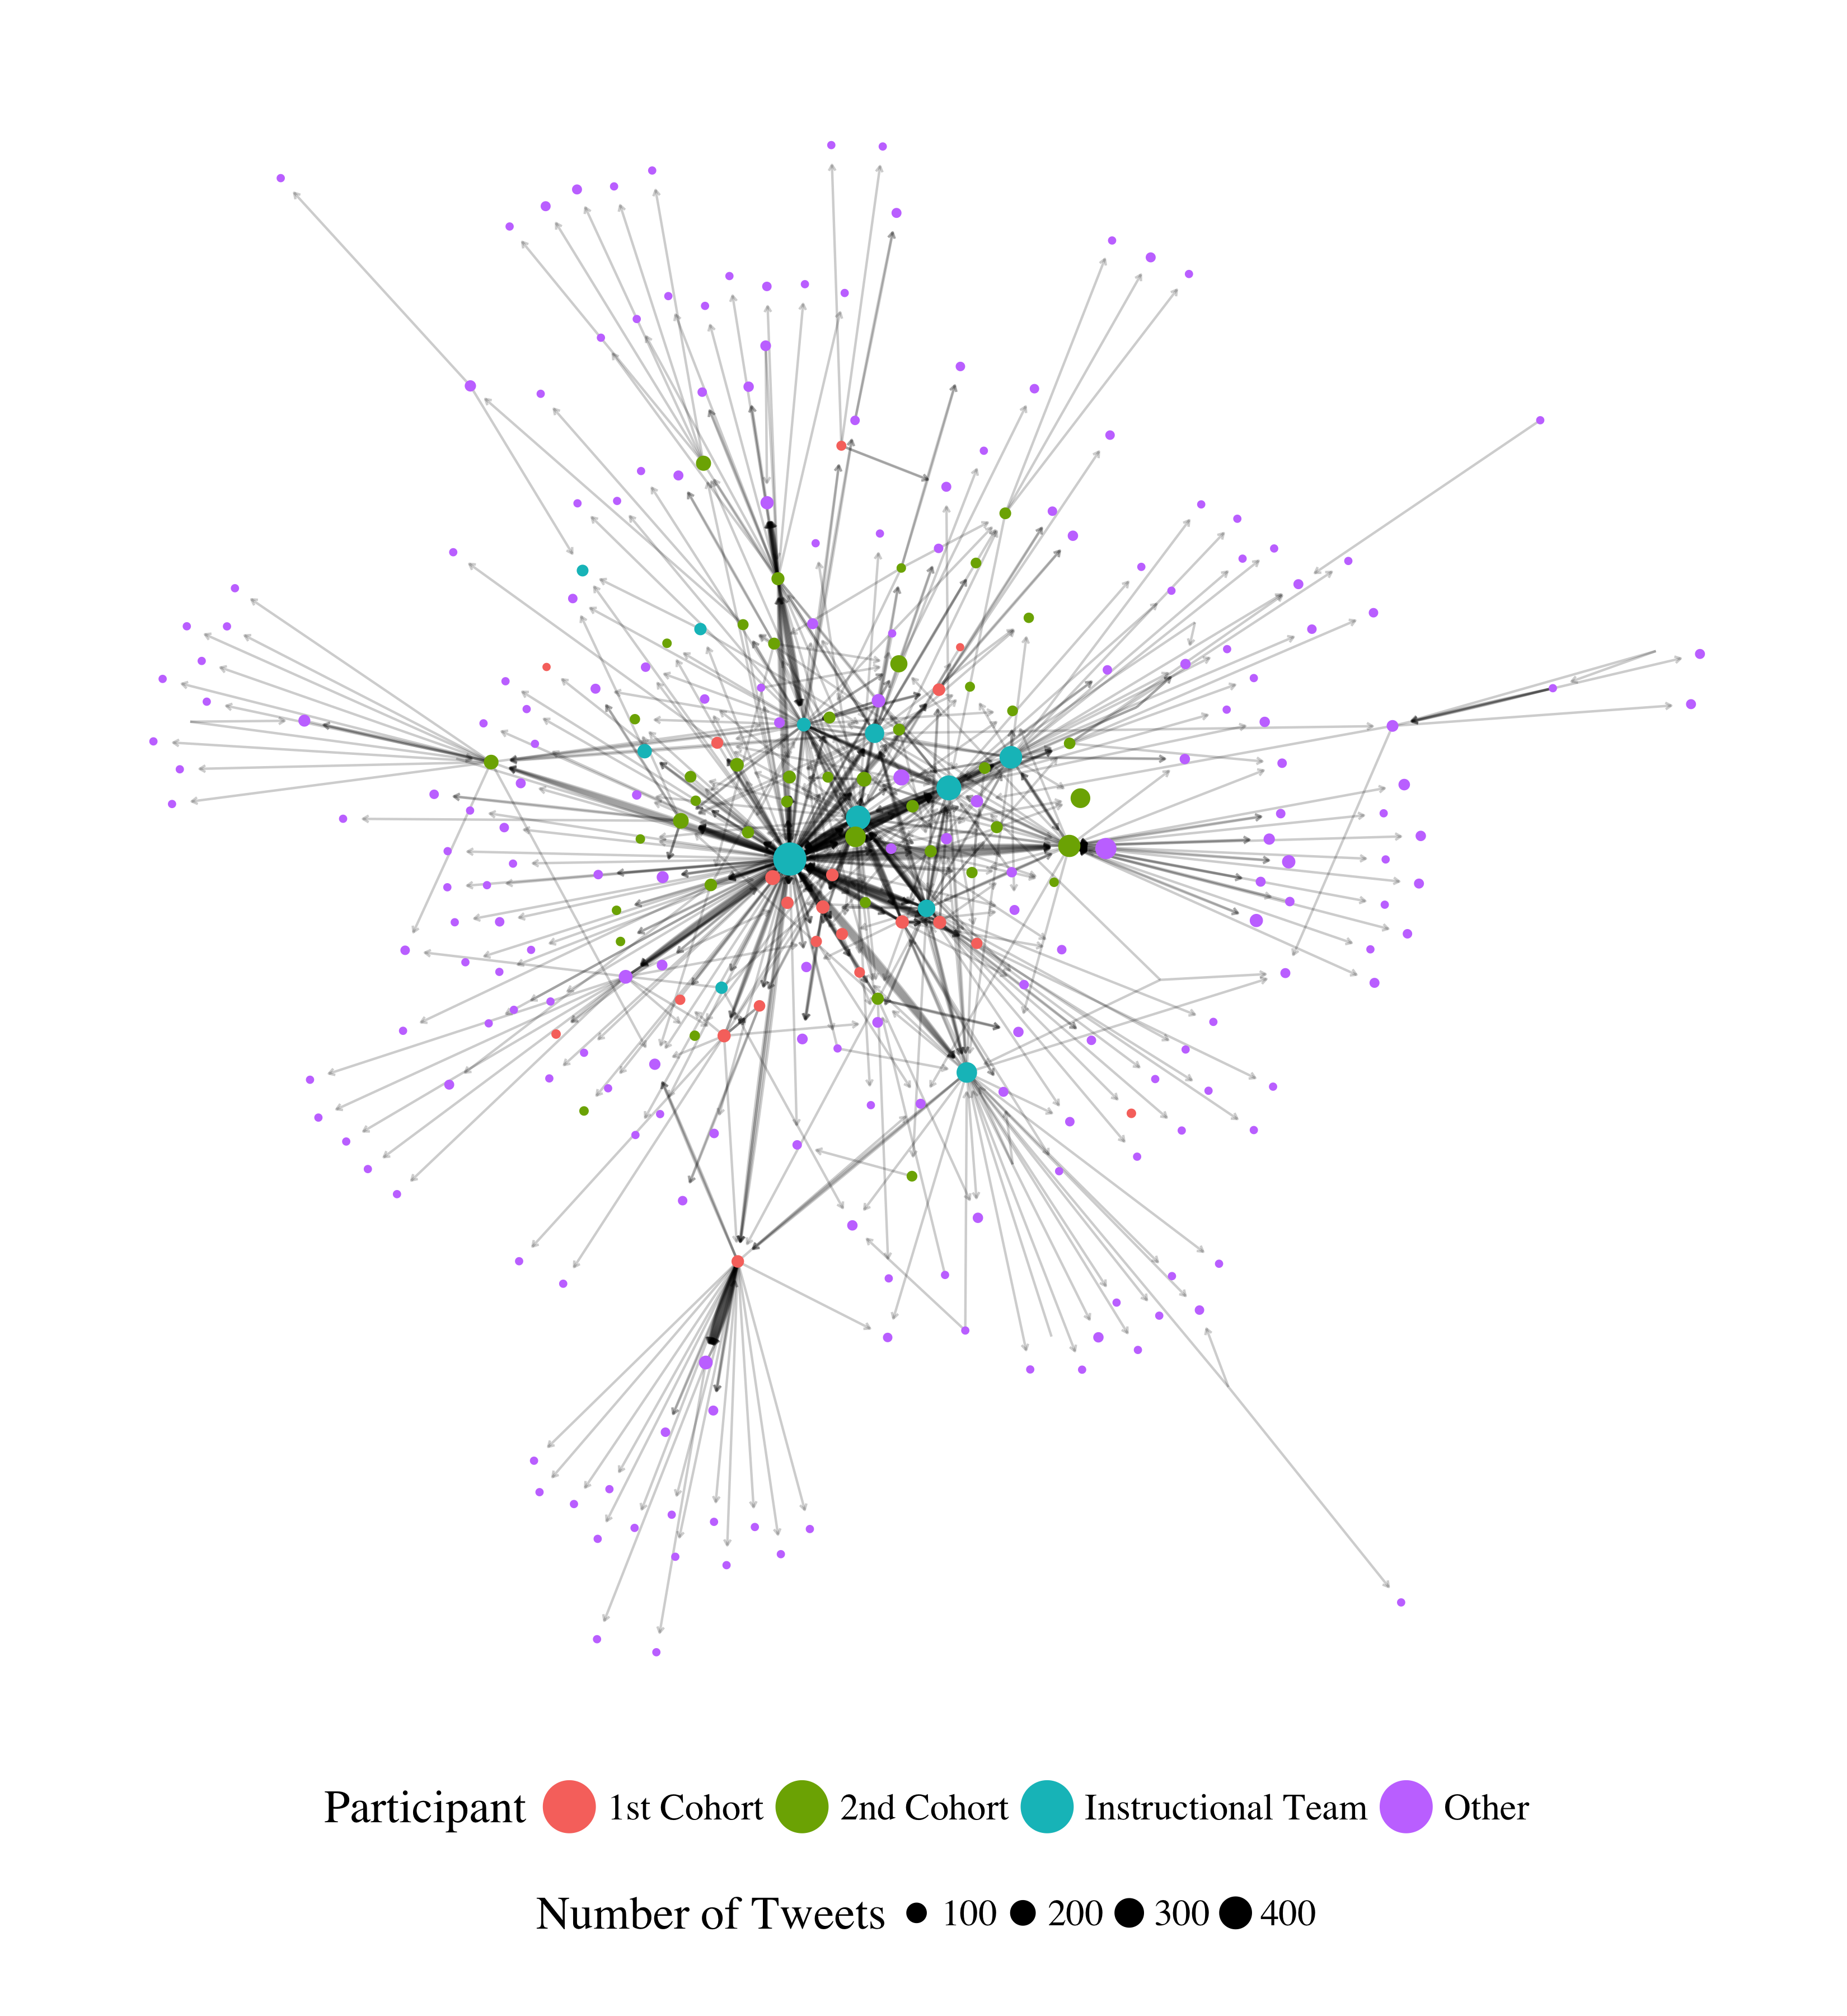

*Figure 5.* Sociogram depicting conversing with patterns within the #MSUrbanSTEM hashtag for UrbanSTEM cohorts 1 and 2.

Note. In this analysis, every participant who conversed with (replied to or mentioned the author of a tweet) a tweet within the #MSUrbanSTEM hashtag is depicted as a vertex (represented as a circle) in the network. Larger-sized nodes represent participants who sent more tweets, or who were more active overall. Every interaction between participants is depicted as a line, with more heavily weighted lines representing more interactions.